A

Practical File

On

Web technology and application lab

For

B.Tech (IT)

At

**IIIT UNA**



Sub. by: Chandan Kumar Sub to: Ms. Akanksha Puri Roll No.: (IIITU17324)

**INDEX**

|  |  |  |
| --- | --- | --- |
| **S.No.** | **Description** | **Sign** |
|  |  |  |
|  |  |  |
|  |  |  |
|  |  |  |
|  |  |  |
|  |  |  |
|  |  |  |
|  |  |  |
|  |  |  |
|  |  |  |
|  |  |  |
|  |  |  |
|  |  |  |
|  |  |  |
|  |  |  |
|  |  |  |

**1). Write a program to implement Html tags and Html forms:**

<html>

<head>

<title>To implement html tags and html forms</title>

<form action="#" target="_blank">

<fieldset>

<legend>Personalia:</legend>

Date of birth: <input type="number" value="26">

</fieldset>

<input type="radio" name="gender" value="male" checked> Male<br>

<p>First Name :</p>

<input type="text" name="identity" value="Rahul" placeholder="Enter your name"><br>

<label>Last Name :</label><br>

<input type="text" name="identity" value="Aggarwal" placeholder="Enter your name" required><br><br><br><br>

<input type="checkbox" name="random" value="cool" checked>Cool<br>

<input type="submit" value="Submit">

<input type="reset" value="Reset">

</form>

<body>

</body>

</head>

</html>

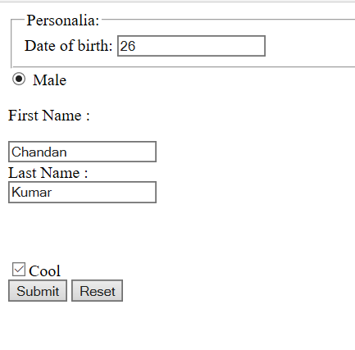

**2).Write a program to add, multiply, subtract and divide two numbers using JavaScript:**

<!DOCTYPE html>

<html>

<head>

<meta charset=utf-8 />

<title>JavaScript program to calculate add, subtact, multiplication and division of two numbers </title>

<style type="text/css">

body {margin: 30px;}

</style>

</head>

<body>

<form>

1st Number : <input type="number" id="firstNumber" /><br>

2nd Number: <input type="number" id="secondNumber" /><br>

<input type="button" onClick="multiplyBy()" Value="Multiply" />

<input type="button" onClick="divideBy()" Value="Divide" />

<input type="button" onClick="add()" Value="ADD" />

<input type="button" onClick="subtract()" Value="Subtract" />

</form>

<p>The Result is : <br>

<span id = "result1"></span><br>

<span id = "result2"><br></span><br>

<span id = "result3"><br></span><br>

<span id = "result4"></span></p>

<script type="text/javascript">

function multiplyBy(){

num1 = document.getElementById("firstNumber").value;

num2 = document.getElementById("secondNumber").value;

document.getElementById("result1").innerHTML = "Multiply : " +num1 * num2;

}

function divideBy(){

num1 = document.getElementById("firstNumber").value;

num2 = document.getElementById("secondNumber").value;

document.getElementById("result2").innerHTML ="Divide : "+ num1 / num2;

}

function add() {

num1 = Number(document.getElementById("firstNumber").value);

num2 = Number(document.getElementById("secondNumber").value);

c=num1 + num2;

document.getElementById("result3").innerHTML = "add : "+ c;

}

function subtract() {

num1 = document.getElementById("firstNumber").value;

num2 = document.getElementById("secondNumber").value;

c=num1-num2;

document.getElementById("result4").innerHTML = "subtract : "+ c;

}

</script>

</body>

</html>

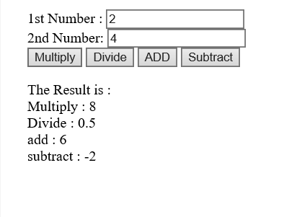

**3). Write a program to declare and print array using JavaScript:**

<!DOCTYPE html>

<html>

<body>

<h2>JavaScript Arrays</h2>

<p id="demo"></p>

<script type="text/javascript">

var cars = ["C", "B", "A",1];

document.getElementById("demo").innerHTML = cars;

</script>

</body>

</html>

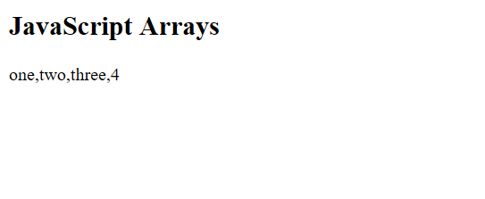

**4). Write a program to update an array using JavaScript :**

<!DOCTYPE html>

<html>

<body>

<h2>JavaScript Arrays</h2>

<p id="demo">

<p id="demo1"></p>

<script type="text/javascript">

var arr = ["C", "B", "A",1];

arr.pop();

document.getElementById("demo").innerHTML = arr;

arr.push(3);

document.getElementById("demo1").innerHTML = arr;

</script>

</body>

</html>

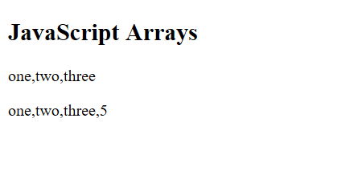

**5).Write a program to implement JavaScript functions :**

<!DOCTYPE html>

<html>

<body>

<h2>JavaScript Functions</h2>

<p>Result : </p>

<p id="demo"></p>

<script>

function myFunction(p1, p2) {

return p1 * p2;

}

document.getElementById("demo").innerHTML = myFunction(5, 3);

</script>

</body>

</html>

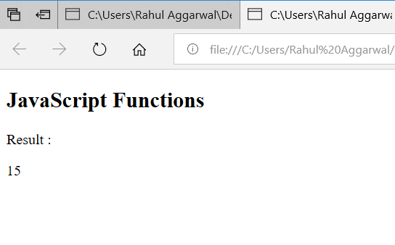

**6. Write a program to implement various styles and border using CSS**

<!DOCTYPE html>

<html>

<head>

<style>

p.one {

border-style: solid;

border-color: #0000ff;

border-width: thick;

}

p.two {

border-style: dotted;

border-color: #ff0000 #0000ff;

}

p.three {

border-style: double;

border-color: #ff0000 #00ff00 #0000ff;

border-width: thin;

}

p.four {

border-style: solid;

border-color: #ff0000 #00ff00 #0000ff rgb(250,0,255);

border-width: 2px 3px 10px 5px;

}

</style>

</head>

<body>

<p class="one">One-colored border!</p>

<p class="two">Two-colored border!</p>

<p class="three">Three-colored border!</p>

<p class="four">Four-colored border!</p>

</body>

</html>

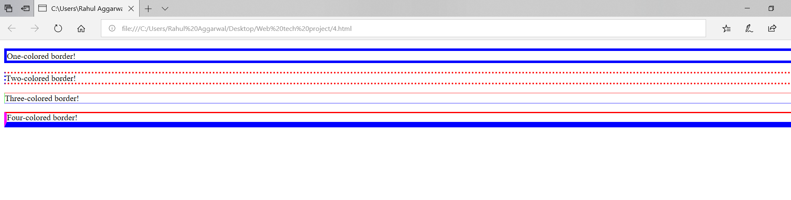

**7. Write a program to implement Framesets in an HTML web page:**

<!DOCTYPE html>

<html>

<frameset cols="25%,*,25%" >

<frameset rows="25%,*,25%" >

<frame src="abc.jpg">

<frame src="2H.jpg">

<frame src="1e.jpg">

</frameset>

<frame src="wp.jpg">

<frame src="1e.jpg">

</frameset>

</html>

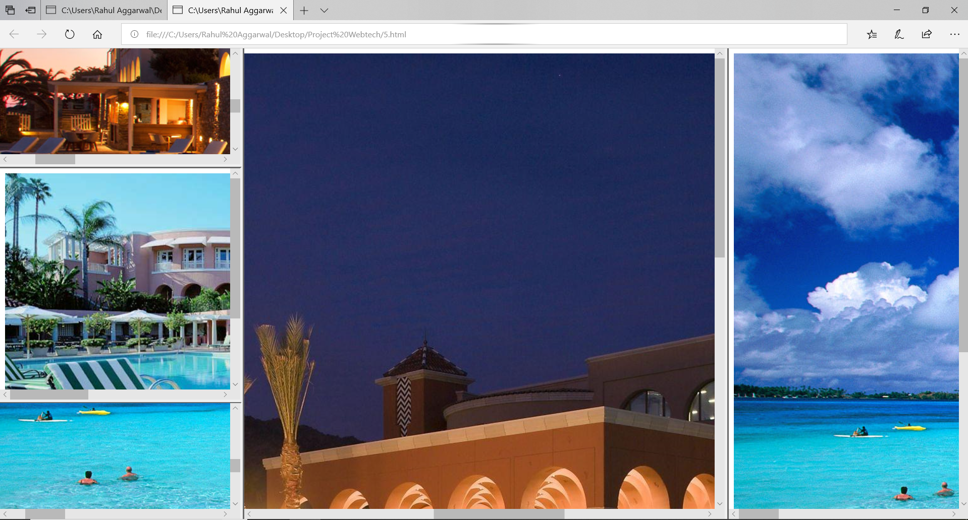

**8).Write a program to implement XML**

<?xml version="1.0" encoding="UTF-8"?>

<breakfast_menu>

<food>

<name>Tes</name>

<price>$1.25</price>

<calories>50</calories>

</food>

<food>

<name>Cardamom Tea</name>

<price>$1.5</price>

<description>

With added cardamom

</description>

<calories>60</calories>

</food>

<food>

<name>Ginger Tea</name>

<price>$1.75</price>

<description>

With added ginger

</description>

<calories>70</calories>

</food>

<food>

<name>Mix Tea</name>

<price>$2.00</price>

<description>

With everything

</description>

<calories>100</calories>

</food>

</breakfast_menu>

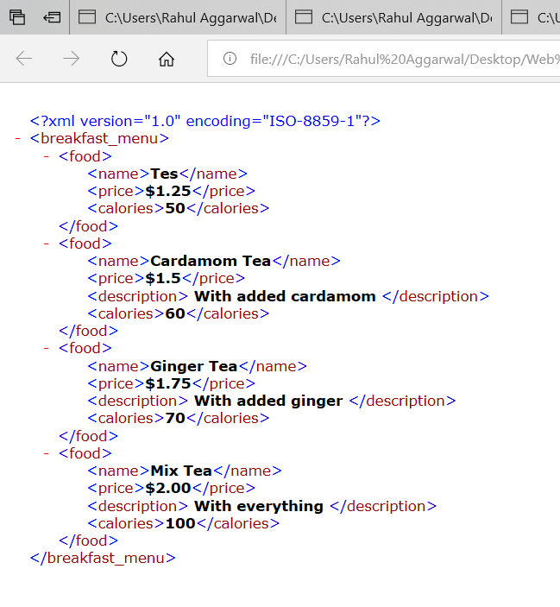

**9. Write a program to add, multiply, subtract and divide two numbers using php:**

<?php

$text="add :";

$text1="subtract :";

$text2="multiply :";

$text3="divide :";

$x = 5;

$y = 4;

echo "<h4>" . $text . "</h4>";

echo $x + $y;

echo "<h4>" . $text1 . "</h4>";

echo $x - $y;

echo "<h4>" . $text2 . "</h4>";

echo $x * $y;

echo "<h4>" . $text3 . "</h4>";

echo $x / $y;

?>

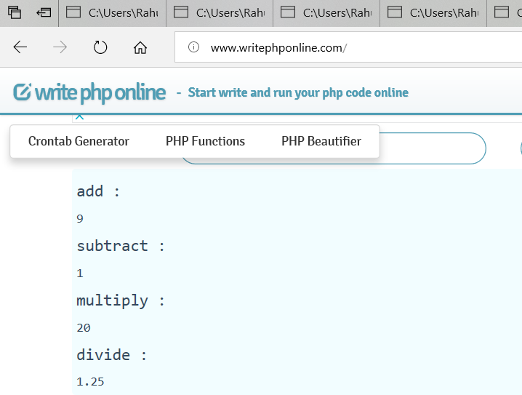

**10. Write a program to declare both kind of array and access its elements:**

**Numerically Indexed array**:

<?php

$personal_info=array('raj','30','6');

echo("Name of employee : ".$personal_info[0]);

echo("<br/>age of employee : ".$personal_info[1]);

echo("</br>Work experience of employee : ".$personal_info[2]);

?>

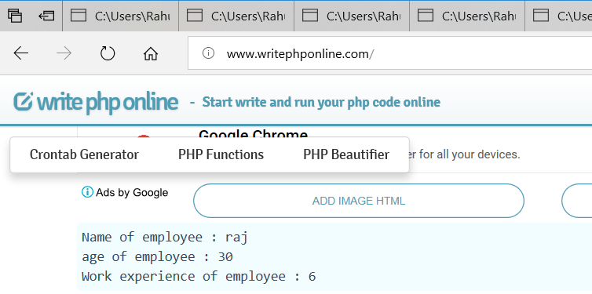

**Associative array:**

<?php>

$friends = array(‘name’ => raj, ‘age‘=> 30, ‘work’ =>6)

echo("Name of employee : ".$friends[‘name’]);

echo("<br/>age of employee : "$friends[‘age’]);

echo("</br>Work experience of employee : ".$friends[‘work’]);

?>



**11. Write a program to implement php functions**

i). php function with returning value:

<?php

function sum($no1, $no2){

$sum2 = $no1 + $no2;

return $sum2;

}

echo sum(3,5);

?>

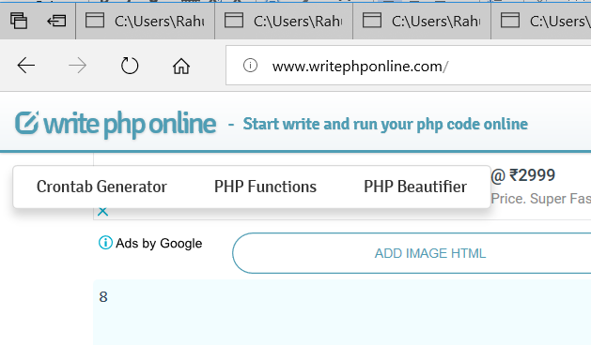

ii). passing argument by reference

<?php

function abc($x)

{

$x=$x-10;

return($x);

}

$a=50;

echo abc($a)."<br>";

echo ($a);

?>

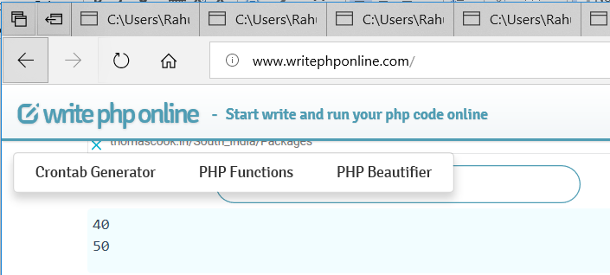

**12. Write a program to implement MySQL commands:**

mysql> show databases;

6 rows in set (0.02 sec)

mysql> use first;

Database changed

mysql> show tables;

Empty set (0.04 sec)

mysql> create table user(name varchar(20) not null default "student",roll_no varchar(20) primary key default "iiitu173_");

Query OK, 0 rows affected (0.64 sec)

mysql> insert into user values("rahul aggarwal","IIITU17332");

Query OK, 1 row affected (0.20 sec)

mysql> insert into user values("shagun aggarwal","IIITU17335");

Query OK, 1 row affected (0.09 sec)

mysql> insert into user values("shashank diwedi","IIITU17333");

Query OK, 1 row affected (0.19 sec)

mysql> delete from user where name="shagun";

Query OK, 0 rows affected (0.00 sec)

mysql> delete from user where name="shagun aggarwal";

Query OK, 1 row affected (0.11 sec)

mysql> update user set status="student" where name="rahul aggarwal";

ERROR 1054 (42S22): Unknown column 'status' in 'field list'

mysql> show tables;

mysql> describe user;

2 rows in set (0.01 sec)

mysql> select * from user;

2 rows in set (0.00 sec)

mysql>

